***LA-BRI’UT* PROFESSIONAL LEARNING**

**A STARTING POINT FOR DIRECTORS**

1. **When starting a session and wanting to acknowledge everyone present:**

Choose one of the “checking in” activities at the end of the curriculum’s introduction, or introduce a similar one. Note that this activity could easily be led each time by a different teacher.

1. **When introducing a new module and wanting to spend time developing deeper understanding of the Jewish value and its use over the five weeks:**
2. TOE-IN-THE-WATER
   1. Ask teachers to read the value’s introduction in the opening pages of the module:

At home, prior to the session noting anything that needs clarification and ideas that intrigue the teacher

OR

In a virtual session in breakout rooms where as a group, participants read paragraph-by-paragraph then:

* + 1. First, ask clarifying questions
    2. Second, share experiences or stories that support what they read
    3. Third, consider how these ideas enrich their thoughts on teaching this value
  1. Show the overview video
     1. At home, prior to the session

OR

* + 1. In the session before moving to breakout rooms

1. DIVE IN
2. In advance of the session, teachers find a visual or auditory image that illustrates an aspect of the value (search images.google.com or pxhere.com). Post to Flipgrid with a note of how the image helps them think about/understand the value.
3. During the session, teachers are given 90 seconds to find something in their home that represents the upcoming value (e.g., for *ometz lev* it would be something that represents the calming of Big Feelings). Participants hold up their items to the camera; discuss a few as a group.
4. Have a straight-forward discussion about any of the following questions in relation to the value and the texts/ideas presented on the Introductory pages:
   * + How does this text/value inspire you as a teacher?
     + How is this text/value relevant to students’ lives?
     + How might families find this text/value a useful tool for navigating their current situation?
     + How might this text/value relate to the current pandemic?
5. Using the ideas in both the introductory pages and overview video for teachers/parents, play “Two Truths and a Lie.” Set up five rounds, each with two things that are true about the value and one that is not. While this could be set up as a Kahoot, the game can also be played simply have having teachers post their response (A, B or C) in the chat or holding up their fingers to the camera (1, 2 or 3 fingers).

Make sure that teachers spend time considering the nuances of the definition for the value under discussion.

1. **When exploring the curriculum guide for the upcoming module:**
2. I SEE IT - A

Divide the staff into groups and ask each to create a flow chart or other visual representation showing the progression of each week in the module. They should start with their week’s “row” in the Grid, and then read through the specific session’s materials. As they talk, one group member could physically draw their diagram OR could use a Word document with arrows and text boxes (or any other app that creates diagrams).

Note: This kind of activity can also be used to help chart the three elements of the Enduring Understanding – how are the teachers EITHER finding where the curriculum lifts up these ideas OR, once teaching, seeing children actualizing them:

If I am not for myself, who will be for me?

If I am only for myself, what am I?

If not not, when?

1. CONFUSIONS, SHARED (at home learning over the course of a week):

Divide teachers in half, or even smaller groupings. Explain that their task is to read through the guide to prepare for teaching the upcoming module.

* 1. On days 1-2 of the week, ask each individual in one of the groups to create a Flipgrid post about something that is confusing.
  2. On days 3-4, ask *everyone* to respond to the postings (even those in the group that offers the confusion-posts)
     1. What do they think the guide’s instructions mean?
     2. How do they think a teacher might proceed?
  3. On days 5-6 ask those who created the confusion-posts to read through what was offered and post back how they will be proceeding.

If repeated for future modules, rotate teachers so different ones are offering the confusion-posts on days 1 & 2.

1. BACK TO THE SOURCES

Share the original texts referenced in the curriculum guide and study them together in *havruta*/breakout rooms or as a full group. Pay special attention to the nuances of the value with the chosen text/story. For instance, for *ometz lev*, how does Moses hiding his face because he was afraid of God illustrate his use of inner strength when he had Big Feelings?

1. BREAK IT DOWN

Teach a lesson with the teachers in the role of learners. When done, use this chart offered by Eileen Sadowsky (Temple Emanu El, Cleveland, OH) to process the elements of the *mifgash* (note that the chart is filled in for a particular session led by Eileen). Teachers help with the wording for each of the columns, engaging in rich conversation as they discuss. Eileen notes that this helps teachers make the connection between the words on the curricular page and “teacher-moves” during a session. She says that it helps teachers better understand the teaching nuances of *La-bri’ut*.

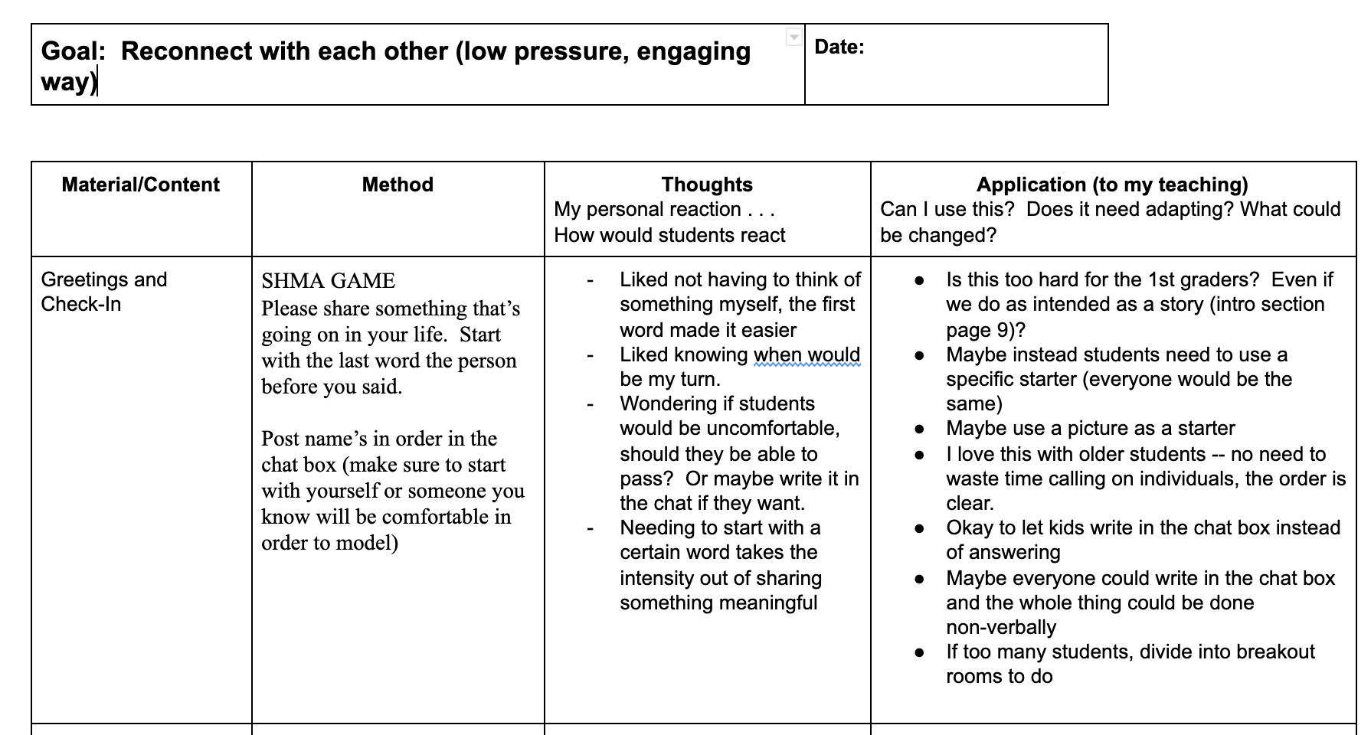

1. **When talking globally about how things are going:**
2. SIGNAL IT – RED OR GREEN: Teachers take a minute to find two things they can hold in their hands – one red and one green (this is similar to one of the *mifgash* activities). Offer a variety of taking-temperature statements and each time ask teachers to signal with the green item if that is true for themselves or signal with the red one if not. Stop to discuss a few of the statements, with volunteer respondents. Examples include:
   * I am comfortable handling the Zoom features.
   * I have had at least one session where I finished feeling proud of how things went.
3. WORD CLOUD: Set up a Mentimeter word cloud (<https://www.mentimeter.com/features/word-cloud>) Ask teachers to post ***one word*** responses, making sure they know that the more a word is repeated by those in the group, the bigger it becomes. Depending on the size of your group, you should ask respondents to post three, five or eight times (you want enough responses so that there are multiple words on the cloud). Use one of these examples, or create statements of your own choosing:
   * How they are feeling about facilitating *La-bri’ut*
   * How they believe their students are feeling
   * How their cohort-grouping is working out (by family, by grade, grade clusters, etc.)
   * Feedback their parents are offering

Allow time to build the specific word cloud and then reflect as a group on what they are seeing.

1. PHOTO ALBUMS: (In advance, if possible) ask everyone to find and share three representative photos to Flipgrid:
   * One that illustrates how they are currently feeling about *La-bri’ut*,

One that illustrates how they think their leaners are currently feeling

* + One that illustrates how they think their parents are feeling

Then, with the faculty

* + Screenshare the photo albums one at a time and ask teachers to jot down some notes on their sense of each, as well as some questions they have.
  + Consider discussing in breakout rooms (one per album? each group discussing all three?) and/or asking teachers to post thoughts in the chat.

1. FEARS, HOPES, AND CALM: This activity could be done in breakout rooms, or anonymously, by having teachers post responses to Flipgrid with unidentifiable usernames created by you.
   * Ask staff first to respond to: “If this year turned out to be one of the worst years ever as teacher, what would be its characteristics?”
   * Then, “If this year turned out to be one of the best years ever as a teacher, what would be its characteristics?”
   * Then, “Considering our fears and hopes, how can we decrease our fears and increase our hopes.” [This last question could be an all-group discussion.]
2. STORYTELLING
   * A teacher prepares a brief teaching/learning story or vignette that illustrates one of the goals of *La-bri’ut* (or any other focus the director desires). The storytelling teacher also:
     + Prepares a question this story raises about moving their work forward.
     + Describes one challenge they have and how they are thinking about addressing it.

To the group, the teacher poses their overarching question, tells their story, and asks their colleagues for specific help thinking through their one key challenge. Discuss.

1. WHAT, SO WHAT, NOW WHAT

In pairs or dyads, have teachers move through a progression of talking about:

* + What: What have I accomplished? What am I working on?
  + So what: In what ways did this learning/session matter to students or me? How did it offer tools and strategies that build resiliency and/or offer new insights into Jewish life and tradition?
  + Now what: What’s next? How do I build on what I have learned about this form of teaching?

Create a group collection of the “now what” responses or ask each group (or teacher individually) to post these to Flipgrid. Encourage teachers to respond to two of the posts.

1. HAPPY DANCE – This is a chance for teachers to share amazing, ah-ha moments that they, their children or parents had/shared. In an all-group session, teachers s share it and thhare a specific anecdote and then everyone does a happy dance in their honor. [Note that these ah-ha moments should be recorded and saved. Posting them to the *La-bri’ut* Facebook group would be inspiring to others and help set direction for *La-bri’ut*’s evaluation/research efforts.]

1. **When reflecting on teaching, especially seeking guidance**
2. CHALLENGES, CUT DOWN TO SIZE
   1. Option One: Divide teachers into small groups and ask each participant to prepare to talk for 2-3 minutes on a challenge they are having during the *mifgash*. To keep the process “tight,” follow the process outlined on the teacher reflection protocol (“protocol – teacher reflection.docx”) on this page of the website: <https://jec-tohealthcurric.weebly.com/for-teachers.html> (20 minutes per teacher)
   2. Option Two: Divide teachers into small groups and ask each participant to prepare to share for 2-3 minutes about a plan they have for an upcoming session. Then have the others listening participate in offering feedback using warm feedback and cool feedback.
      1. Warm feedback offers a thought that points to strengths of the plan. Warm feedback is positive and, yes, warm.
      2. Cool feedback offers thoughts on shortcomings or potential problems with an inquisitive design: I’m wondering why you chose to… I’m curious about … Can you explain …

These formats can also be used to focus on the flow of each module’s week-of-learning, not just the *mifgash*.

1. CHARTING THE FUTURE - Teachers plan an upcoming *mifgash* using the “*mifgash* planning chart” posted to the middle of this page: <https://jec-tohealthcurric.weebly.com/for-teachers.html>. The first time using the chart, consider dividing teachers into pairs or small groups. At other times, consider asking teachers to use the chart to prepare individually for a *mifgash*.

After facilitating/teaching the particular *mifgash*, either in small groups or as a faculty, reflect on how it was useful and what they learned to do differently the next time. If discussing as a full faculty, consider ways to use Zoom’s chat feature to build ideas.

OPTION: Use a modified version of the professional learning model called “Japanese Lesson Study”[1] by having two or more teachers co-plan a lesson together, then each teach the

session to their own learners. The teachers could record their lesson or just verbally describe what happened. Share segments for feedback/ comparison/reflection. Conclude by having each reflect on what they will do similarly the next time and what they will do differently.

1. ONE-ONE-TWO-TWO-FOUR – A teacher shares two photos or videos from their learners’ postings to Flipgrid: one that they feel is an on-target one to the assignment and one that they feel missed the mark. As a whole group, or in break-out rooms (if the latter, timing updates would need to be communicated through the Zoom system)
   1. Spend two minutes identifying elements that define positive characteristics of the on-target example
   2. Spend two minutes identifying where the off-target one missed the mark
   3. Spend four minutes brainstorming ways to launch an assignment that would encourage more on-target submissions
2. **When wanting teachers to reflect on their take-aways from working with *La-bri’ut***
3. I SEE IT – B

Each of these steps use the Mindset-Shift-Comparison chart found at the top of the Curriculum Content page of the website: <https://jec-tohealthcurric.weebly.com/uploads/1/0/6/1/10614651/mindset_shift_comparison.pdf> Teachers will need to download a new copy for each step, below. For those using a PC, while doing a screenshare, demonstrate what happens when you click on the “Fill and Sign” tab on the right; show teachers how to add a checkmark to the chart. For those using a Mac, ask them to go to Preview and then manually write in a checkmark with the pen tool.

* Step One: Towards the end of (or after completing) *Sukkat Shalom*, spend time discussing/defining each of contrasting elements in the two columns. Spend time going through each, making sure that teachers especially understand the nuances of the column on the right. At the end of each row’s discussion, ask teachers to identify whether they feel comfortable with the element from each column as part of their teaching. For each element they are comfortable with (and yes, they might be comfortable with both the right and left column for a particular row), they should place a checkmark in that box. When done, ask them to send you the document via email so you can track their thinking throughout the year. [They can also do this directly on Zoom by clicking FILE >> SHARE]

Discuss which elements in the right-hand column are most challenging and ask for some quick tip ideas from the group, in response.

* Step Two: Towards the end (or after) each of the upcoming modules, give teachers a few moments to put checkmarks on each of the elements themselves. Discuss what is still challenging and what is getting easier. Ask them to send you the chart.
* Step Three: In the discussion after *G’vurah* and the remaining modules consider with the faculty which elements from *La-bri’ut* they’d like to bring forward into next year’s teaching/learning. (You might wish for them to mark those items by circling them or highlighting them in addition to their Step Two checkmarks). How might you be able to help support them in that?

1. <http://www.americanradioworks.org/segments/a-different-approach-to-teacher-learning-lesson-study/>